Figure 1:

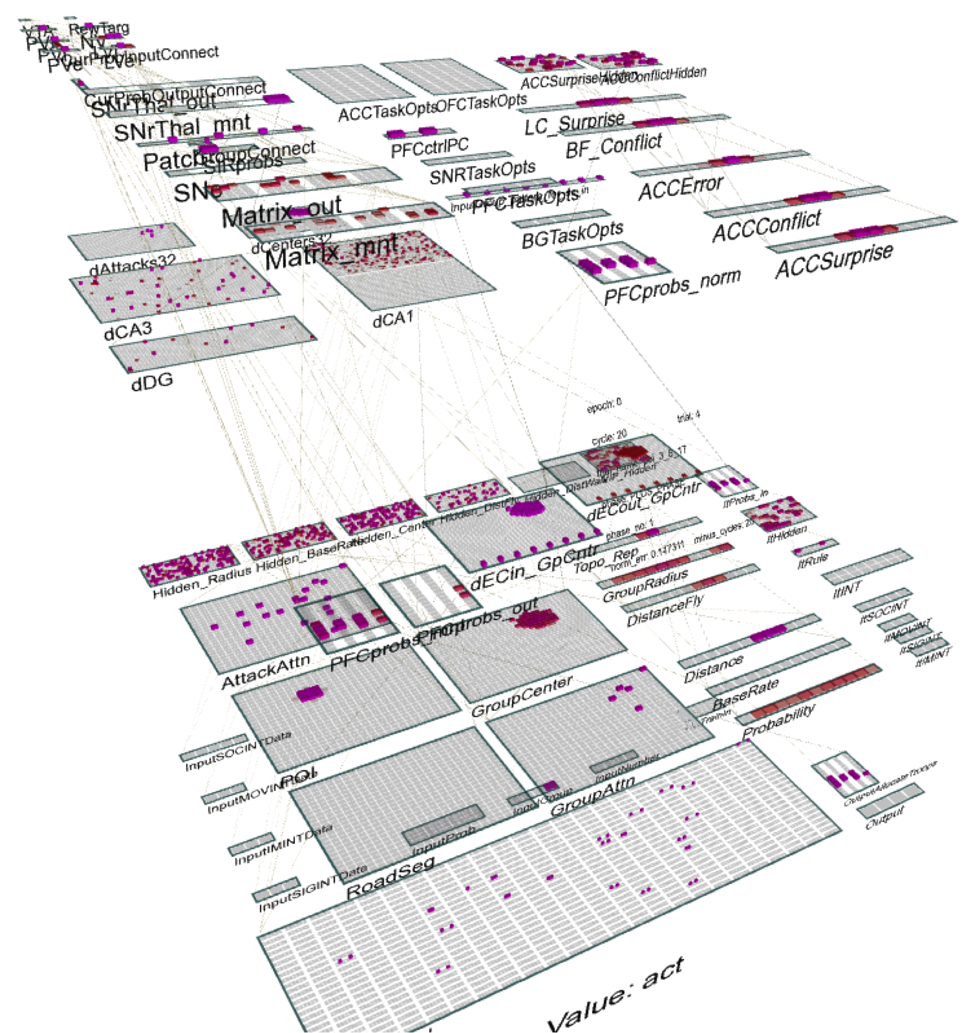

Figure 2:

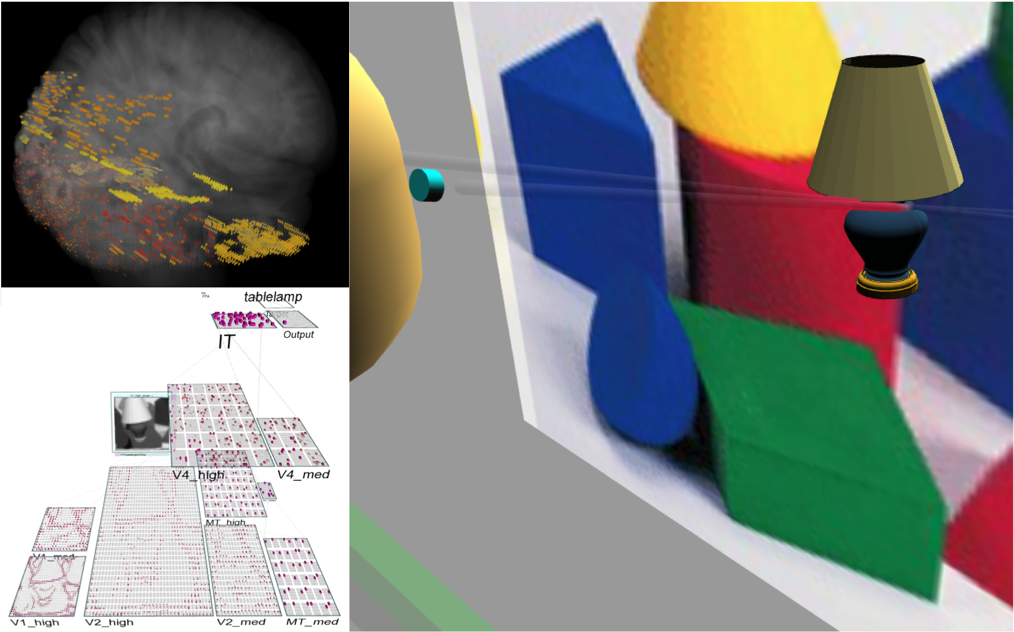

Figure 3:



Figure 4:



Figure 5:



Figure 6:



Figure 7:



Figure 8:



Figure 9:



Figure 10:



Figure 11:

